## Merchant

Demo date: Nov 18, 2024  
Scoping start date: Nov 18, 2024

MSA Signature Date: Nov 27, 2024  
Onboarding Kick Off Date: Dec 5, 2024

[If Exists] Opt Out Date: NA  
Go Live Date: Dec 9, 2024

GTM POC: Sean  
Implementation POC: Royce

ERP: QBO

Tax Integration: No Tax

### 

### Key people at Merchant

### CEO - Ramnandan Krishnamurthy

### 

| Notes Sections [Ops International Team to Ignore] *(AE/ Implementation to fill)*   * Info on how merchant bills   + Still figuring it out - moving 3 pilot customers to paying customers * Is there any important merchant relationship information?  1) What is the merchant temperament? - Great guy, out of NY and India. They are also in the FinTech AI space. Ali created a great relationship with him offering many lunches, connects, and even an intro to investors   2) Is there a key POC: (i.e.: who is the buyer/decision maker?) Just Ram  3) What are the Tabs features that the key POC cares about? AI, automation |
| --- |

### 

### Company summary *(AE to fill)*

Very similar to Tabs except with a focus around closing the books for mid-market/enterprise customers. They view themselves as an ERP add on

Goals (North star)  
*(AE/ Implementation to fill)*

Goal is to automate billing once they have contracts and paying customers

No opt out

### Billing model *(AE/ Implementation to fill)*

All unknown now

* Are there unique things about the customer creation process for this merchant?
* Information on how merchant bills
* How contract is broken up
* One off things to know about the merchant

### 

### 

### 

### 

### 

### Contract Processing Steps *(Implementation/Success to fill)*

1. Steps to process
   1. Scroll to section titled Fees, merchant is requesting to have all invoices sent on the first of the month.

**Service Start Date:**

1. Rule: if the effective is between the 1-15- have it default to the start of that corresponding month (example 01/14/2025 would start the first of January)
2. If the effective date is between the 16-end of month, have it start the following monh
3. (example 01/23/2025 would start 02/01/2025)

**Total months of Service:** This will differ depending on if you are creating a line item for **Implementation** or the **Recurring monthly price** (screenshot example below of where to find service term for implementation and monthly price)

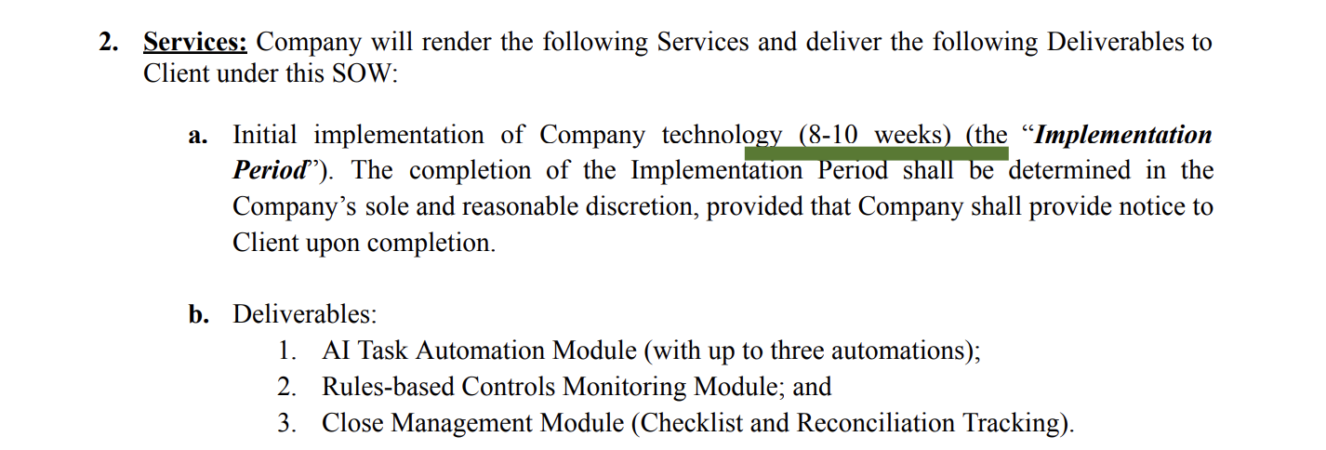

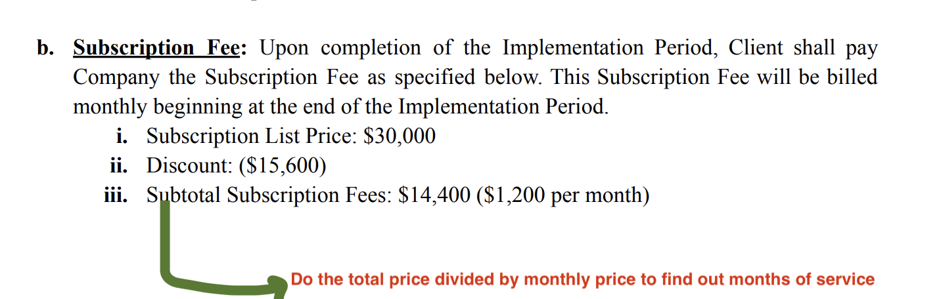

**Item Name:** Subscription Fee or Implementation Fee regarding which one you are working on

**Item Description:** Leave blank

**Integration Item:** Search the item name and it will map to the correct integration item

**Billing Type:** Flat  **Start Date + Total Price:**

* You will have to check the term of the period for **Implementation** to see how long this period should be
  + Note in the screenshot below that the implementation fee is divided 50% on effective date and 50% on completion of implementation period. Make the start dates according to this
  + 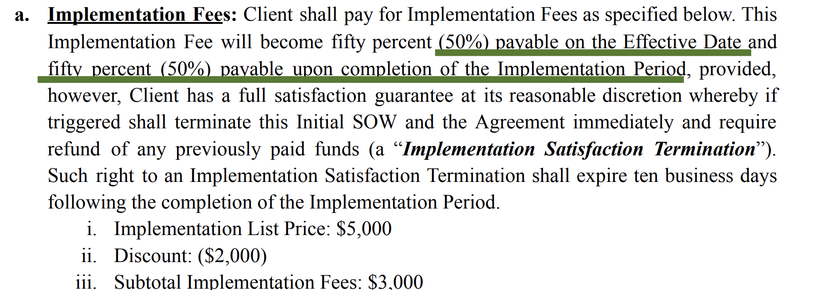
* After the mentioned term length for **Implementation,** you can then build out the start date for the yearly subscription
  + Check the final price, do not include the discounts
    - 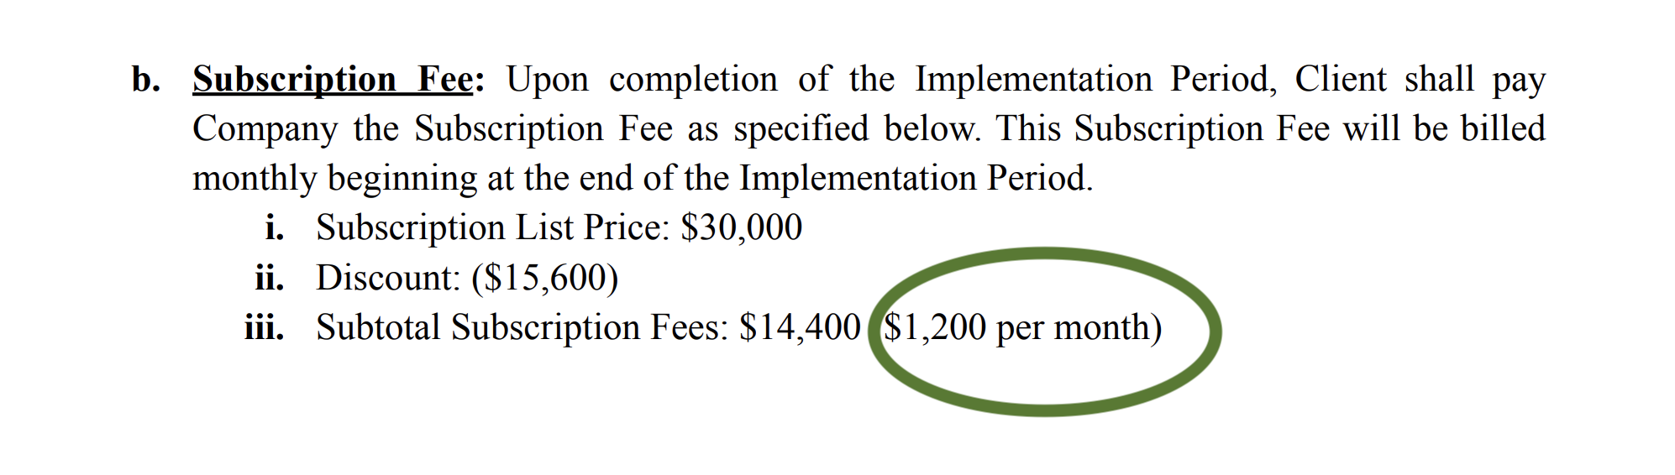

**Periods:** 12 if yearly, this will depend on the amount of months that is listed on the line item

**Frequency:** Monthly if otherwise stated

**Net Terms:** Always 30

1. Anything to ignore in contracts?
2. Specifics processing things the merchant has requested that may differ by contract (e.g. always back-date invoice date to final day of the month)
3. Default Service Term
   1. If None Listed, Ops Default is 1 Year
4. Default Net Payment Terms
   1. If None, Ops Default is 0
5. Default Billing Frequency
   1. If None Listed, Ops Default is Monthly
6. How do we handle taxes as a line item?
   1. If None Listed, Ops Default is every tax line item becomes a BT

### Events Processing (if necessary) *(Implementation/Success to fill)*

* Any important information on events billing

Integration Items Processing (if necessary)  
*(Implementation/Success to fill)*

* What are the instructions for assigning integration items?
* Example: All Statsig integrations items should be labeled as “Sales”
* Example: All “Pinata” integration items should be labeled as “Software Subscription Bundle” unless otherwise noted by Merchant

Post Processing Communications (if necessary)  
*(Implementation/Success to fill)*

* Does the Ops Team need to notify anyone on the team re: completion of processing batches in Implementation or Active phase?
* Who needs to be notified and when?
  + Example:
    - Who: Customer Success [Azmat Aziz] needs to be notified
    - Where: Messari internal merchant channel
    - When: contracts are processed [Merchant Phase: Active]

### Customer Information *(Implementation/Success to fill)*

* Any important information on specifics customers of this merchant
  + Special memo’s certain invoices require
  + Invoice changes due to merchant/customer relationship

### Feature Requests *(AE/Implementation/Success to fill)*

None

* FR 1
  + What is it
  + Why it's important
  + Urgency

### Rewatch Calls *(AE/Implementation/Success to fill)*

First one didn’t record - detailed notes in slack

Second one in slack - a lot of info from the first call was repeated in second call